SQL STATEMENTS

**USERS SECTION**

CREATE TABLE users (

id INT PRIMARY KEY AUTO_INCREMENT,

firstname VARCHAR(100) NOT NULL,

surname VARCHAR(100) NOT NULL,

email VARCHAR(100) NOT NULL,

age INT NOT NULL

);

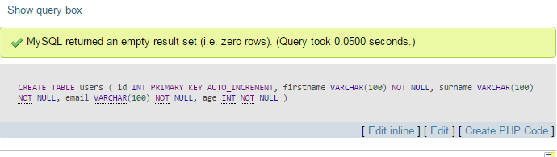

ALTER TABLE users ADD UNIQUE INDEX(email);

**CATEGORIES SECTION**

CREATE TABLE categories (

categories_id INT PRIMARY KEY AUTO_INCREMENT,

name VARCHAR(100) NOT NULL,

description VARCHAR(100) NOT NULL,

user_id INT,

FOREIGN KEY (user_id) REFERENCES users(id)

);

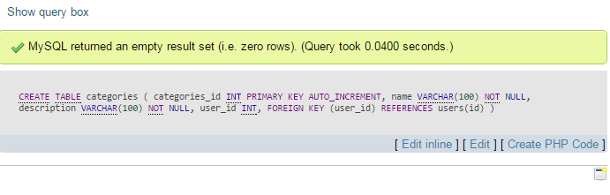

**SUB CATEGORIES SECTION**

CREATE TABLE sub_categories (

sub_categories_id INT PRIMARY KEY AUTO_INCREMENT,

name VARCHAR(100) NOT NULL,

description VARCHAR(100) NOT NULL,

user_id INT,

categories_id INT,

FOREIGN KEY (user_id) REFERENCES users(id),

FOREIGN KEY (categories_id) REFERENCES categories(categories_id)

);

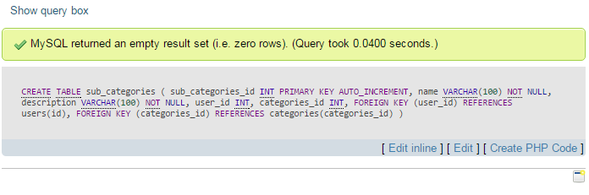

**LINKS SECTION**

CREATE TABLE links(

links_id INT PRIMARY KEY AUTO_INCREMENT,

name VARCHAR(100) NOT NULL,

description VARCHAR(100) NOT NULL,

url VARCHAR(100) NOT NULL,

user_id INT,

categories_id INT,

sub_categories_id INT,

FOREIGN KEY (user_id) REFERENCES users(id),

FOREIGN KEY (categories_id) REFERENCES categories(categories_id),

FOREIGN KEY (sub_categories_id) REFERENCES sub_categories(sub_categories_id)

);

